|  |
| --- |
| JPanel |
|  |
|  |

|  |
| --- |
| JFrame |
|  |
|  |

|  |
| --- |
| FontMetrics |
|  |
|  |

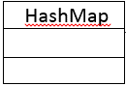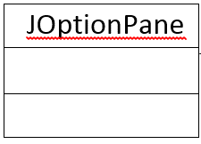

|  |
| --- |
| TheWindow |
| int child2child  boolean dirty  Dimension empty  FontMetrics fm  JFrame frame  JOptionPane message  HashMap nodeLocations  int parent2child  HashMap subtreeSizes  BinaryTree tree |
| void actionPerformed(ActionEvent)  void calculateLocation(Node, int, int, int)  void calculateLocations()  Dimension calculateSubtreeSize(Node)  void drawTree(Graphics2D, Node, int, int, int)  void paint(Graphics) |

|  |
| --- |
| Dimension |
|  |
|  |

|  |
| --- |
| BinaryTree |
| Node root |
| Node addNode(int)  Node addTo(Node, int)  Node deleteNode(int, Node)  Node findMin(Node)  Node getRoot()  Node searchNode(int, Node) |

|  |
| --- |
| Node |
| int content  Node left  Node right |
| int getContent()  Node getLeft()  Node getRight()  Node setLeft(int)  Node setRight(int) |